***CMPE 281 – Cloud Technology – Lab # 3***

***Playing with Salesforce***

**Name: Navit Gaur**

**Submitted to: Professor JERRY GAO**

**Perform the following steps:**

1. **Create a developer account on salesforce by signing up on** [**developer.salesforce.com**](http://developer.salesforce.com)

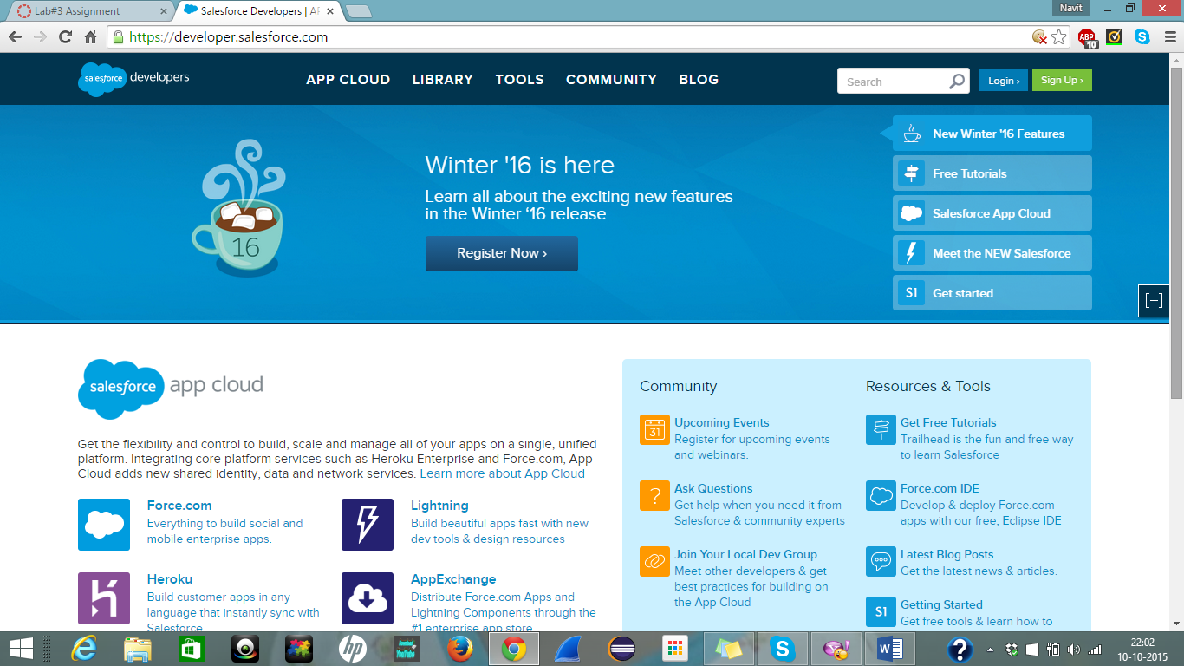

1. Enter your details like first name, last name, email etc.

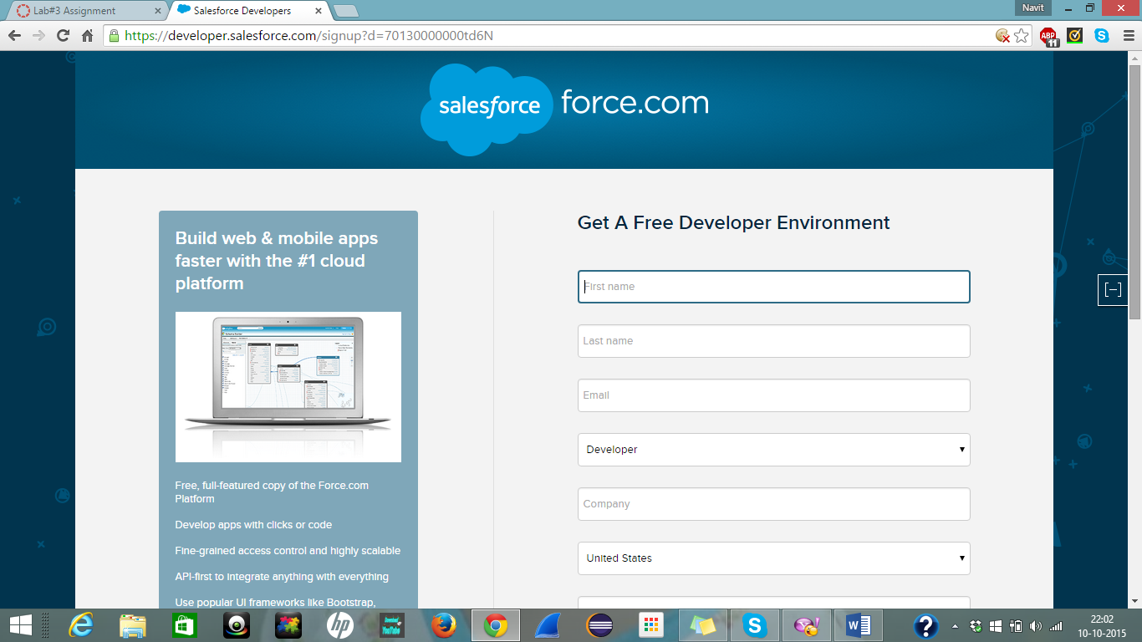

1. Create a password and login.

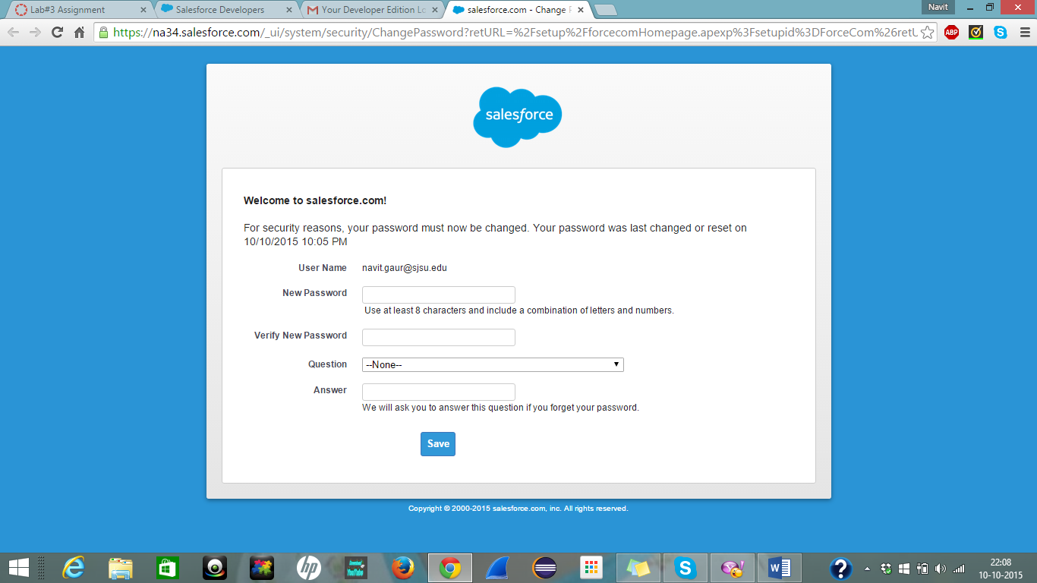

1. Once you login, click on Add App to create your application

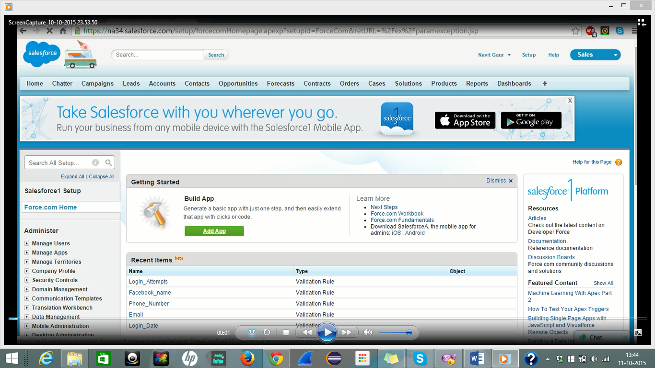

1. Give the name to your application…in my case it is Students

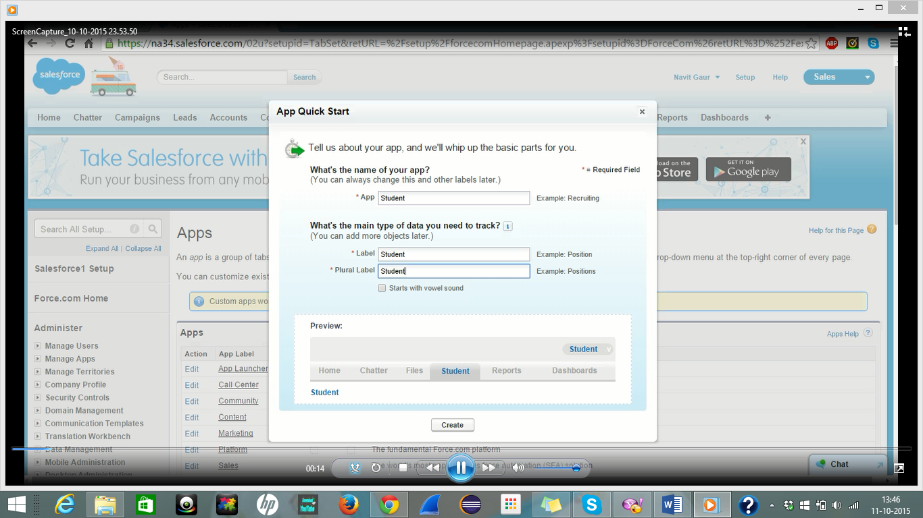

1. Click on Setup tab on right top corner. Then under Create option click on Objects to see your Student object.

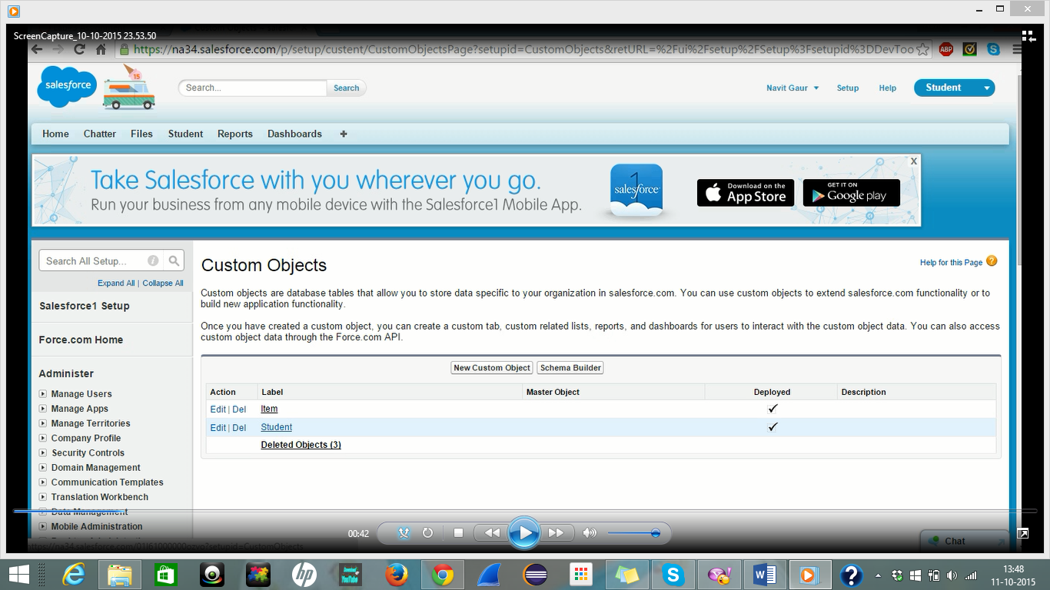

1. Under Student navigate to Custom Fields and Relationships and Click on NEW.
2. Select the attribute according to your requirement. I selected TEXT and click on next.

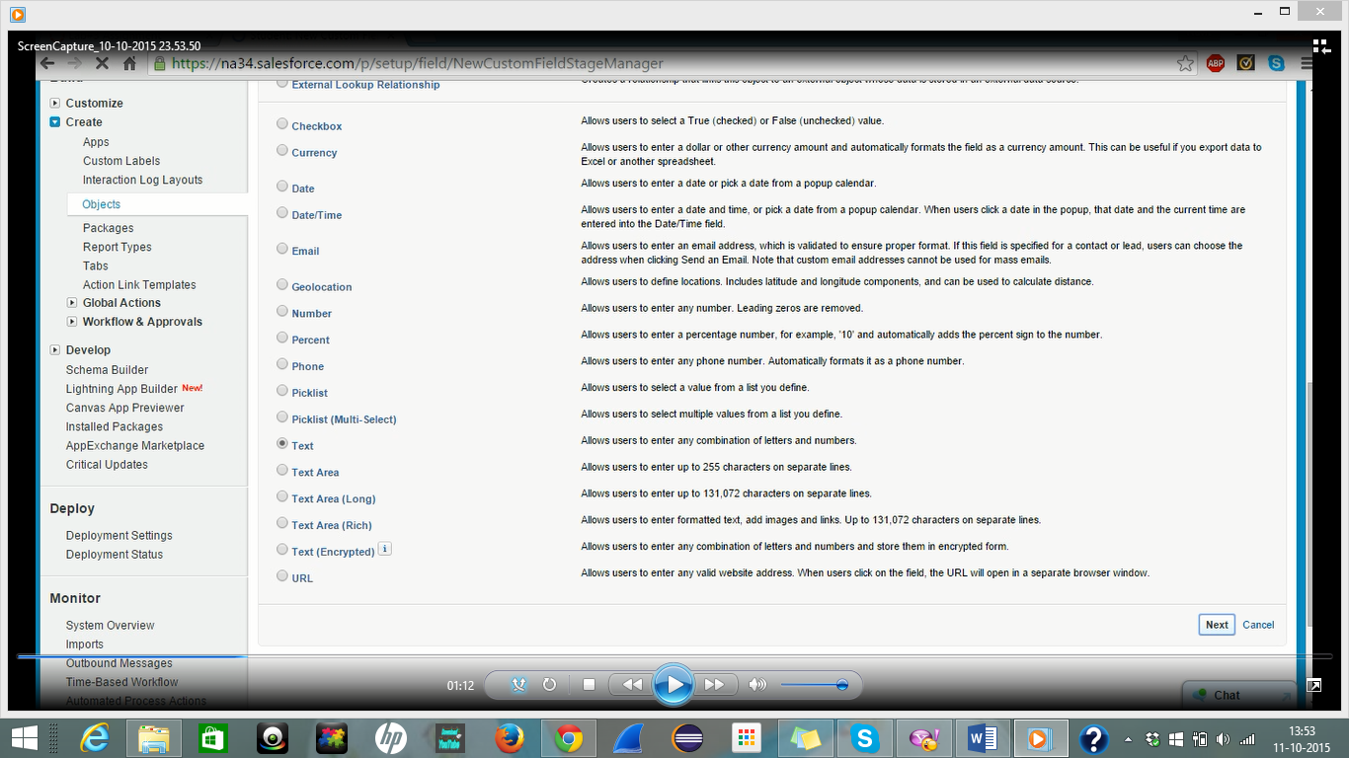

1. Enter the Field Name, Label, and Description. In my case I entered Student Name as label, Student_Name as Name. Checkmark the Required field since it is needed and click next.

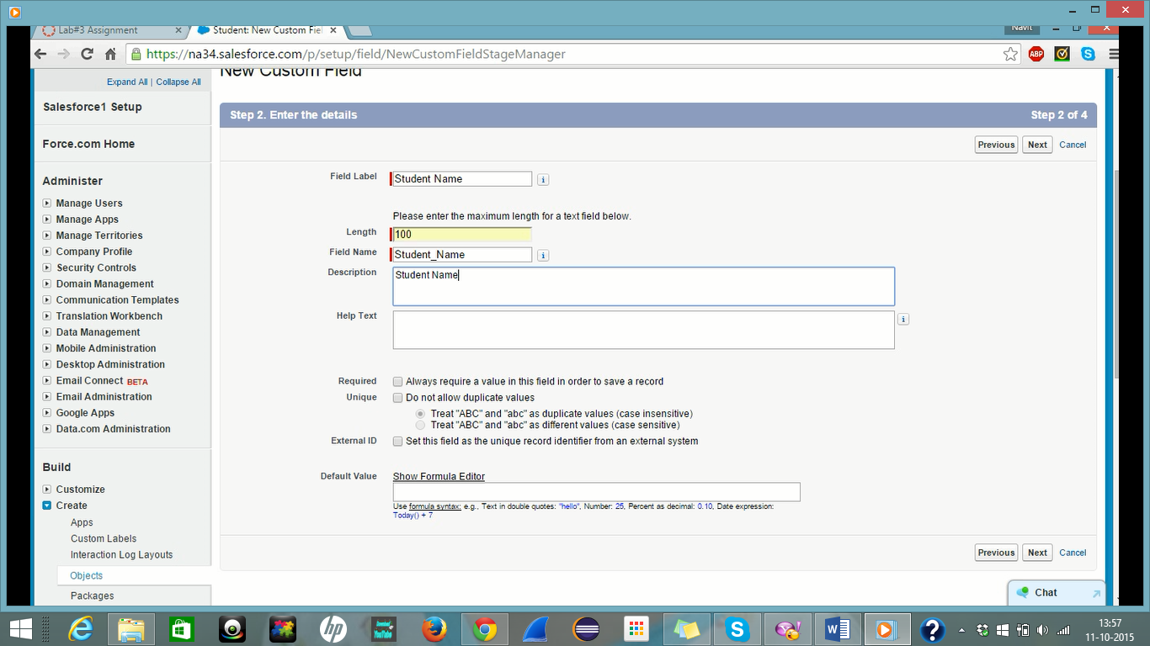

1. In the same way I created 4 more attributes namely :
2. Email : to enter email of student
3. Phone Number : to enter phone number of student
4. Login date : to enter date of login
5. Login Attempts: to enter number of login attempts.
6. Now we have to set validation rules. So under Student object move to Validation rules and click on NEW.

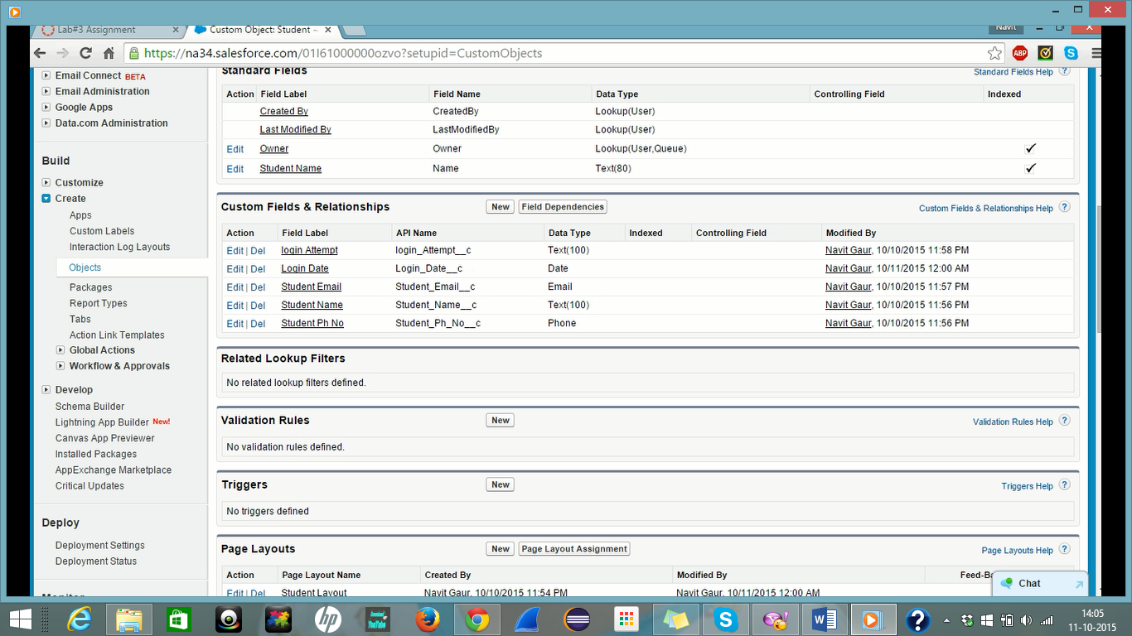

1. Enter Rule name, Description. In my case I added Student_Name as rule name. Then select a function from insert function tab and in the method parameter area enter your parameter from the insert field tab. In my case it is ISNULL(Name).

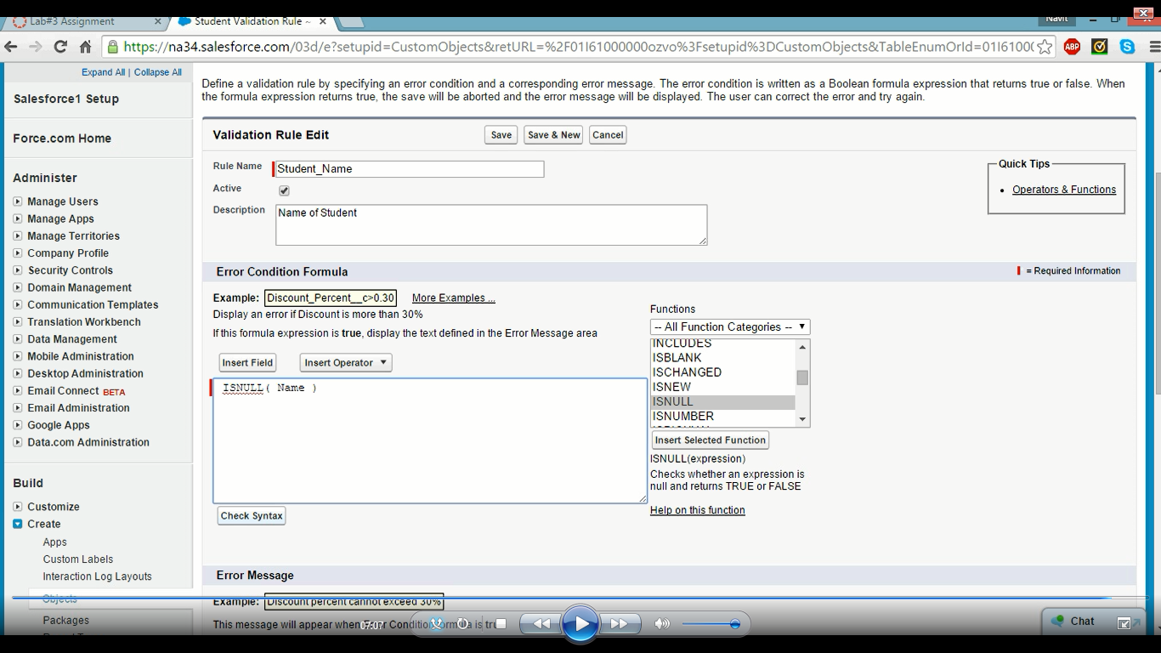

1. Enter the error message to be displayed and click save and new.

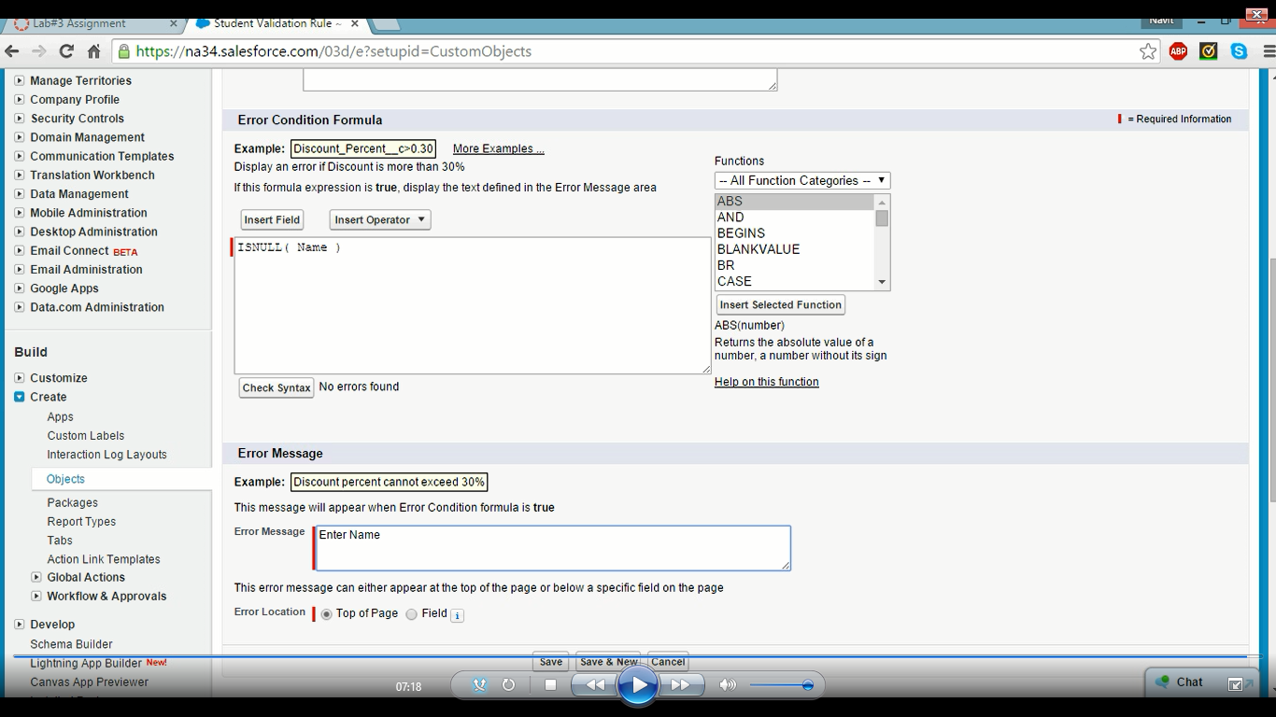

1. In the same manner create validation rules for other 4 fields as well.
2. Click on Student tab at left top corner and click on NEW to enter records.

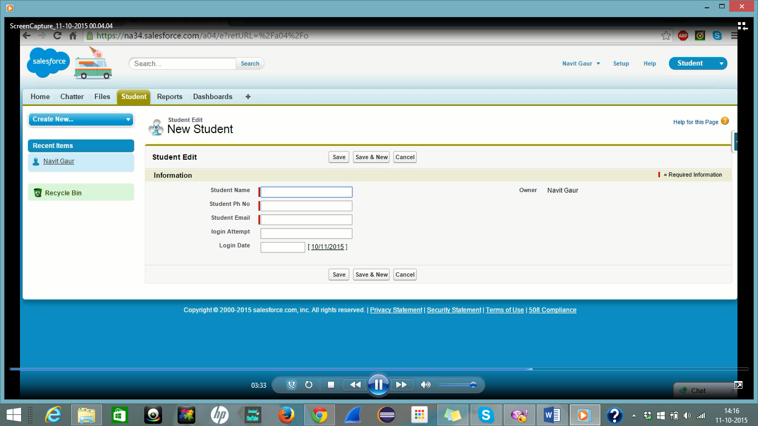

1. To check validation rules every time leave any one of the required field blank to check the error message. I left email blank

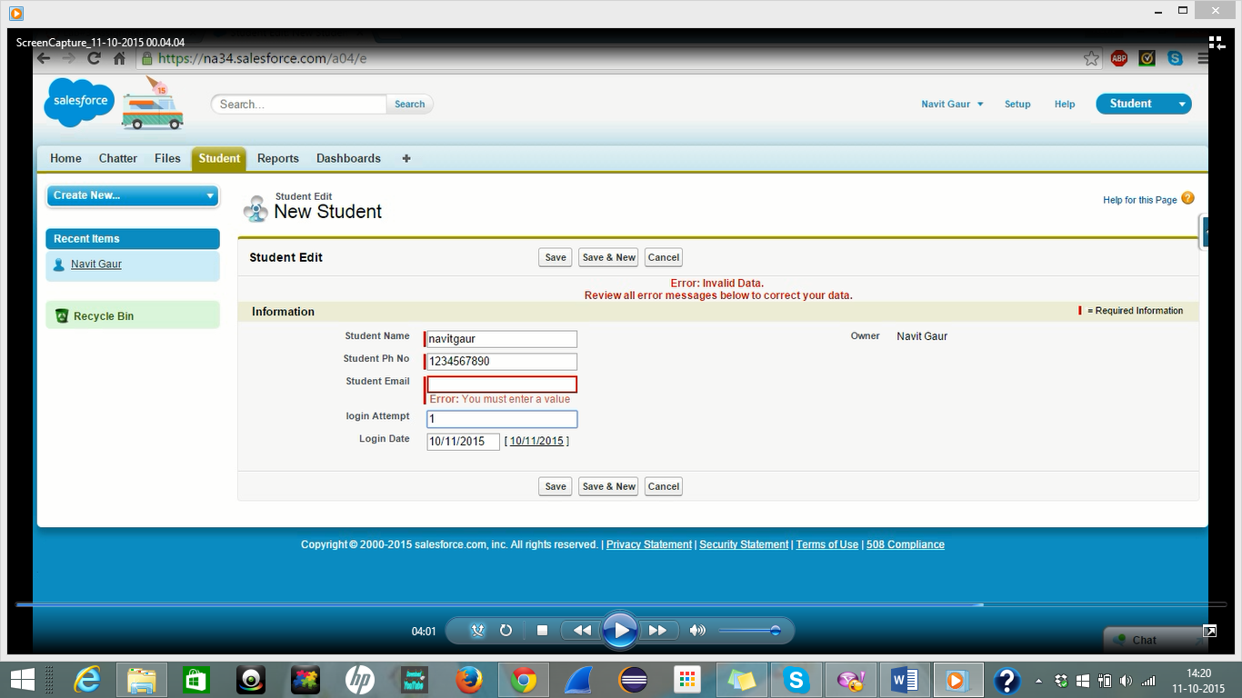

1. Similarly you can check for Name and Phone Number as well.
2. Once everything is fine and all fields are validated click on Save to save your records.

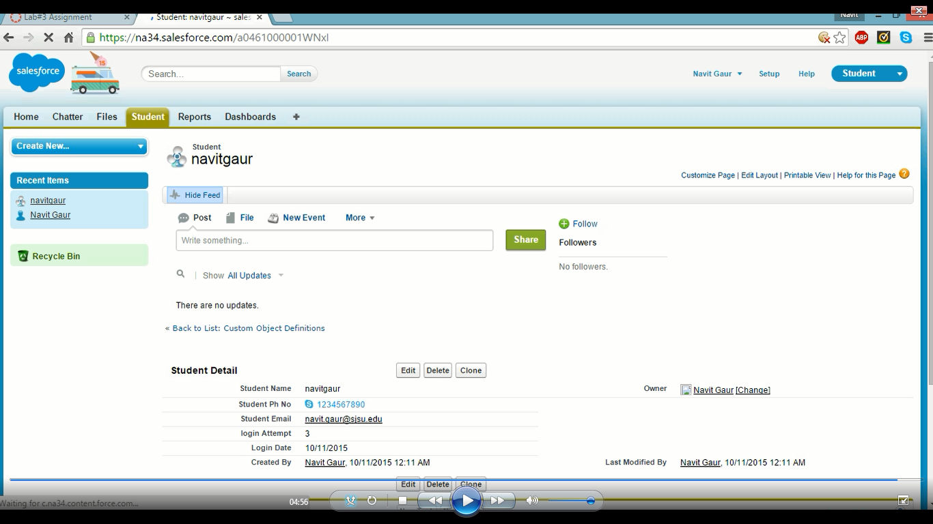

***Thank You***

***Submitted By:***

**Navit Gaur**